## **Client profile:** GCON Office Furniture was established in Guangxi, China in 1995. At that time, GCON is one of the leading manufacturers which sells furniture in Guangxi Province. In 2010, GCON expanded their business to Brisbane, Australia and located their warehouse in Archerfield, South Brisbane area. The company employs 3 staff members in Australia.

GCON Furniture mainly focus on providing wholesale office furniture and hotel furniture to other companies or customers. Their aim is to provide high-quality furniture to customers in a safe and eco-friendly condition. GCON also provide customised services, which design unique furniture to satisfy customer’s specific needs and wants. For customers who find it inconvenient to purchase in physical store, GCON has established their own website (<http://www.gconfurniture.com.au/)> for online shopping. GCON also set their web store on Ebay, which is one of the largest E-shop website to attract more potential customers. Moreover, GCON use social media to increase their brand awareness such as Facebook(3 followers), Twitter, G+ and WeiBo(43 followers).

GCON aims to provide the most suitable and personalise services to customers with their proudly products and become a pioneer of furniture industry one day.

**Market analysis:** After being a well-known brand in China, GCON Office Furniture entered to Australia market in 2010 to gain more market share. It mainly targets consumers who need modern office furniture or hotel furniture in Queensland. Surprisingly, the largest demand observed is designing personalised office furniture apart from buying those prepared in stock. The biggest competitor of GCON Office Furniture is Empire Furniture who offers the similar products and services with longer history in Australia. To compete with them, the Australian branch of GCON Furniture relies on importing top tier product from mainland factory. This allow GCON to gain advantages to differentiate with other competitors.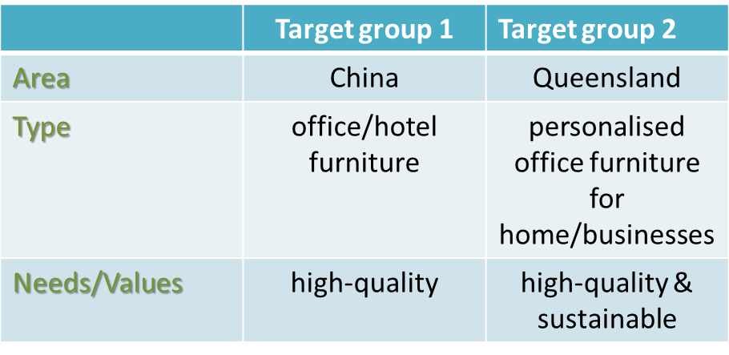

According to the table above, GCON has the vision to provide the most suitable and personalised service to achieve different requirements. As a popular furniture company, they put great concern about sustainability and provide environmental-friendly furniture. Furthermore, GCON Furniture ONLY focus on office furniture rather than kitchen furniture or bedroom furniture as its specialty. In particular, GCON Furniture mainly serve within Queensland which means it could pay more attentions to the high quality of its service.

**Current Marketing:** GCON attach importance to customers from both online and offline channels. Since GCON opened their subsidiary corporation company in 2010 in Australia, they aim to provide top-class products for Australian with the widest range of office furniture. They established an English website for Australian and other english-speaking customers (<http://www.gconfurniture.com.au/)>. GCON furniture attempts to satisfy customers’ needs by creating social media platforms in recent years. Therefore, advertising through the internet is the easiest way to expand their brand awareness. 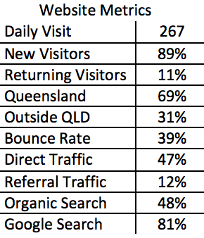

According to Google Analytic, the website has an average daily page visit of 267 times and 11% of them are returning visitors. They are most likely to buy in their second visit. In addition, most of the customers purchase in store have visited GCON website before. This can show the usefulness of the website. Despite, there are still rooms of improvement in areas of page layout, incomplete catalog and mobile interface support.

**Conclusion:** Online information gathering is always a key factors to determine consumer’s behaviour and decision making. Although GCON furniture currently does not have a sufficient online platform to promote their product, we strongly believed that using Google Adwords along with our campaign can definitely increase their brand awareness.

## **Proposed Adwords Strategy**

## Proposed AdWords Strategy: The primary goal of AdWords marketing is to generate greater sales in both revenue and volume, while the secondary goal is to raise awareness to the public. In order to reach these goals effectively, four Google Search Network strategies and one Google Display Network strategy will be used.

## Screen Shot 2017-04-09 at 17.21.17.png

## Apart from the Search Network campaigns, one Display campaign is made to attract more potential customers and to raise the reputation of the company in Australia. The targeting of the ad campaign will be done in behavioural and demographic segments which are those self-employed and aged between 30-50. The Ads will be shown based on keywords like home office, working at home and self-employment to have a widespread visibility.

Negative keywords such as -“Garden Furniture’’ -“Kitchen Furniture” and -“Second Hand” will be used in each of the AdGroup to exclude untargeted customers from clicking on our ads. Using Google Keyword Planner and Google Trends will effectively analysis potential and existing keywords. In addition, exact keyword matching will help in enhancing the CTR. The main goals of the campaign are to increase the number of people visiting the website and purchase through the online channel. CPC manual bidding is taken to set bids for the greatest value in achieving the goals and minimising the cost. There will be 3-4 Ads in each AdGroup rotated manually. To further control the performance, keywords with high CPC or low CTR will be banned after evaluation and replaced by other keywords suggested by Google Keyword Planner.

## Two example ads for the campaign are shown below in table.

## Screen Shot 2017-04-09 at 17.21.31.png

## 

The campaign will use behavioural, demographic and geo targeting techniques. The demographics for the campaign will be both male and females in the workplace. It will be aimed at 25-45 year olds who are in of need office furniture. The geo targeting will be directed at locations with a high density of people such as the Brisbane CBD, Gold Coast and Sunshine Coast. This will be performed by the use of postcodes and IP addresses. There are a high amounts of business and corporations that are within these areas. This means that the advertising campaign will gain more exposure and be viewed more frequently. In addition to this, the social media avenue will target customers that are frequently looking at pages that are associated with business. This will mean that the consumer is more likely to pay attention to the ad. Another route for advertising may be the use of mobile ads as this is a market that isn't not taken advantage of. Generally speaking, a business man or woman has a phone for the majority of their day.

**Budgeting**With the $250 dollars that has been provided, the multiple aspects of the campaign must be allocated money based on the priority and usefulness of the strategy. The online presence is the most important as this is how the company is aiming to grow in the market. Money should also be allocated to search engine bidding as optimising the search engine results is crucial in increasing sales.

A goal of the company will be to sell 40 of the “executive desk B” within the length of the campaign. Valued at $599 this will result in $23,960 of revenue**.** The length of the campaign is 4 weeks, therefore the budget should be reflect the growth that comes from the ad campaign. Therefore the 1st week will be allocated the least amount of money, 20%. In order to to this the search volume and the CTR the must increase. In order to do this, the company will devote the majority of the budget to search advertising through Google Search Network and revenue conversion techniques using Google Display Network strategy . Week one will mainly focus on creating awareness.

|  |  |  |  |
| --- | --- | --- | --- |
| **Weeks** | **% of budget** | **Break down** | **Daily** |
| Week 1 | 20%=$50 | $40 to Google Search Network  $10 to Google Display Network strategy | $5.17  $1.43 |
| Week 2 | 25%=$62.5 | $32.5 Google Search Network  $30 to Google Display Network strategy | $4.64  $4.29 |
| Week 3 | 25%=$62.5 | $30 to Google Search Network  $32.5 to Google Display Network strategy | $4.29  $4.64 |
| Week 4 | 30%=$75 | $25 to Google Search Network  $50 to Google Display Network strategy | $3.57  $7.14 |

**Objectives and KPIs**

The objectives that have been stated is to, firstly increase sales, and secondly increase awareness. The metrics that will judge whether this will be successful or not is the conversion rates, ROI and search volumes.

The company expects to generate a ROI of 95%. This will be done through discounts, bundle deals and email subscriptions.

In addition to this, the company also aims to have a CTR of 0.5%, without spending more that $0.5 per click.

These metrics will be a guide to the success of the campaign. If the advertising campaign is to generate the revenue that is expected, then the CTR needs to be increasing throughout the course of the campaign and CPC needs to be at an effective operating level.

**Maybe look at emails to pre-existing customers, reminding them every year to buy furniture.**

**budget table, goals for impressions and proposed success metrics  
  
  
  
  
  
  
  
  
  
  
  
  
  
  
  
  
  
  
  
  
  
Formatting Requirements**

All reports should use the following formatting:

* PDF Format
* 12-point Times Font
* Text in any Tables and Figures is no smaller than the equivalent of 10-point Times font
* 2.54cm/1in Page Margins (keep all Tables and Figures within the stated 2.54cm/1in page margins)
* A4 or US Letter Sized Paper (usually the standard paper size in the 'Page Layout' section of most word processing programs)
* Left-justification
* 1.5 Line Spacing
* **No** cover page, title page, or table of contents
* **No** footnotes

Reports that exceed the page limit or ignore the formatting guidelines will be disqualified. Also, do not include information that shows your team members' names or institutional affiliation (e.g., college, university).

**IMPORTANT:** Please use the following file name formatting when submitting your reports:

* AdWords Pre-Campaign Report: **preAW-***[YOUR GOMC PARTNER'S NAME]***.pdf**
* AdWords Post-Campaign Report: **postAW-***[YOUR TEAM'S CID]***.pdf**

*If you upload a report multiple times using the same filename, a string of numbers and letters will automatically be appended to the end of the file name. That is okay, as long as the beginning of the file name includes the above mentioned information.

To see examples of winning AdWords Pre-Campaign and Post-Campaign Reports, visit the [Past Challenges](http://www.google.com.au/onlinechallenge/past/index.html) page and navigate through years.

[Here](http://www.youtube.com/watch?v=cfPaQiIvsk8) you may find some advice on the importance of following GOMC's Guidelines.

## **Report Length and Language Options**

* AdWords Pre-Campaign Report can be a maximum of 4 pages
* AdWords Post-Campaign Report can be a maximum of 8 pages
* Impact Statement can be a maximum of 2 pages, appended to the Post-Campaign Report

Reports can be submitted in any one of these 16 languages: English, Spanish, French, Italian, German, Chinese, Korean, Arabic, Russian, Portuguese, Japanese, Polish, Hungarian, Turkish, Czech, and Hindi.

## **AdWords Pre-Campaign Report (Judged on a total of 30 points)**

The AdWords Pre-Campaign Report has three components:

1. Client Overview that describes your client's business (12 points)
2. Proposed Adwords Strategy (13 points)
3. Communication and Readability (5 points)

Ideally, students should gather input from their clients in developing the Adwords Pre-Campaign Report.

### **1. Client Overview (12 points, about two pages)**

As a foundation for the proposed AdWords Strategy, this section should provide a brief overview of the client and its current marketing initiatives.

#### **Client Profile (2 points):**

* Name, Location
* Number of employees
* Goods and services offered
* Key online marketing and website management personnel
* Age of the company
* URL
* Social media such as Google+, YouTube, Blog, Twitter, Facebook etc.
* Company presence and sales via online and offline channels
* Other relevant information

#### **Market Analysis (4 points)**

* Current and potential customers
* Current and potential competitors
* Overview of the industry (key characteristics, competitive/saturated/mature)
* Market position/specialties
* Unique selling points of the goods/services offered
* Seasonality of their goods/services or seasonality that the company has identified
* Other relevant market information

#### **Current Marketing (4 points)**

* Website uses, e.g. sales, customer service, email subscriptions, etc.
* Website strengths and weaknesses
* If available, summary information from Google Analytics or other third party web tracking software
* Other online advertising and offline promotion of the website

#### **Conclusion (2 points)**

* How does the AdWords Campaign align with the client's business?

### **2. Proposed AdWords Strategy (13 points, about two pages including sample AdWords ads and keywords)**

Based on an analysis of the client, its website and marketing, each team should craft an appropriate AdWords Strategy and goals for their campaign. The proposed strategy should include:

* Number of campaigns, campaign types used and the focus for each campaign
* A sampling of keywords, negative keywords and other targeting methods
* Text for at least two text ads of an ad group and summary of any other ad types used, if applicable
* Daily and weekly plans for spending their campaign budget
* Network(s) for their AdWords ads
* Ad serving options
* Keyword bidding strategies
* Location targeting
* Goals for impressions, clicks, CPC and CTR
* Proposed success metrics
* Other relevant information

### **3. Communication and Readability (5 points)**

The AdWords Pre-Campaign Report should have a logical flow, be easy to follow, and avoid grammatical mistakes.